**Project TumorTrace: MRI-Based AI for Breast Cancer Detection**

Infosys SPRINGBOARD 5.0

Name : G. Rebekah Rose

Company Name : Infosys

Role : AI/ML Intern

Duration : 7th October 2024 – December 2024

Linkedln : <https://www.linkedin.com/in/rebekahrose2003/>

Github : <https://github.com/thatgirlAnansi/TumorTrace>

Mobile no : +91 9573651939

**Table of contents**

* Selection and Offer Letter Mail
* About Infosys Springboard 5.0
* Information about the Internship Role
* Day to Day Internship Activity Log
* Description of internship experience
* Conclusion

# Selection and Offer Letter Mail



# Infosys Springboard 5.0 Internship

The **Infosys Springboard Internship Program** is an excellent learning opportunity for students/ learners who are aspiring professionals to hone their existing skills and transition to global corporate professionals.

The Infosys Springboard Internship is a great opportunity to work with the best minds in Infosys and help implement the theoretical concepts learned, to the practical field of work. This is your opportunity to be initiated from academia into a professional work experience. You will complete your internship virtually without the constraints of a physical location. You will get to work on some very intriguing projects and also experience the life of a workplace.

**Domains Covered**

Choose one from five domains:

* Artificial Intelligence and Machine Learning (AI/ML) 
* Java
* Web Development
* Python
* Data Visualization (Business Intelligence)

**Internship Structure**

Selected candidates will join as Project Interns under the Infosys Springboard program. Each mentor supervises approximately 20+ interns, supported by additional staff. Despite being unpaid, the experience is invaluable, offering practical exposure akin to a traditional office setting.

**Each intern is assigned a project relevant to their chosen field, divided into four milestones over an 8-week period:**

* **Initial Two Weeks:** Daily one-hour video meetings during weekdays to establish project foundations.
* **Following Weeks:** Video meetings are held on alternate days to facilitate progress and provide guidance.
* **Milestone Three:** Focus on creating a user interface for the project.
* **Final Milestone:** Individual documentation and project presentation by selected team members.

**Engagement and Expectations**

Tasks are assigned with varied deadlines, ranging from two to four days. In case of exams or other pressing commitments, extensions can be requested via email. Attendance is crucial, with only a few absences permitted for urgent reasons.

The internship emphasizes not just technical skills but also teamwork and project management. The final milestone involves a project presentation, where a subset of interns handle the presentation and demonstration.

**Duration:**The maximum duration is 3 months (12 weeks).

**Mode:** The internship will be virtual. Subject to the pandemic conditions, if we introduce the option of hybrid internship models, we will communicate the same along with the guidelines.

## Infosys

Infosys is a global IT services and consulting company that provides business consulting, information technology, and outsourcing services

Infosys values diversity and inclusion, emphasizing a work culture that celebrates different perspectives and backgrounds. The company is committed to providing equal employment opportunities, ensuring that every employee is treated with respect and dignity, regardless of their gender, ethnicity, or background. This inclusive approach helps create a collaborative and innovative environment where diverse ideas can thrive.

By fostering an inclusive work environment, Infosys aims to empower its workforce to bring their best selves to work. The company promotes various initiatives and programs that encourage learning, development, and career growth for employees across all levels. This focus on talent transformation helps employees develop new skills and capabilities, which aligns with Infosys' vision of continuous improvement and adaptability.

Moreover, Infosys' commitment to diversity extends beyond the workplace. The company actively participates in community engagement programs and collaborates with various organizations to promote social and economic inclusion. Through these efforts, Infosys aims to contribute positively to society and build a more inclusive future.

# Domain: Artificial Intelligence and Machine Learning

The AI/ ML internship required us to complete pre-requisite courses to enhance our skills. The courses offered are:

* **Agile and Scrum Practices**:
* **Agile Scrum in Practice** focuses on Agile project management methodologies, emphasizing the Scrum framework. It covers key principles like sprint planning, daily stand-ups, sprint reviews, and retrospectives.
* **Prioritization of User Stories** and **Story Point Estimation** introduce methods to rank and estimate user stories, ensuring that the most critical tasks are addressed first, and team efforts are efficiently allocated.
* **DevOps and Agile** explores the integration of Agile methodologies with DevOps practices to streamline development and deployment processes.
* **User Stories** and **User Story Activity 1** teach how to create and manage user stories effectively, emphasizing the importance of capturing requirements from the end-user perspective.
* **Emerging Technologies and Software Development**:
* **Computer Vision 101** introduces the basics of computer vision, exploring how machines interpret visual data.
* **Introduction to Robotic Process Automation (RPA)** covers the fundamentals of automating repetitive tasks through RPA tools, enhancing productivity.
* **Introduction to OpenAI GPT Models** and **OpenAI GPT-3 for Developers** provide insights into the capabilities of OpenAI's language models, emphasizing their application in natural language processing tasks.
* **Introduction to Data Science** and **Introduction to Natural Language Processing (NLP)** offer foundational knowledge on data analytics, machine learning, and processing human language data.
* **OpenCV for Beginners** introduces the OpenCV library, a popular tool for computer vision tasks, focusing on image and video processing.
* **Professional Skills Development**:
* **High Impact Presentations** focuses on enhancing presentation skills, covering aspects like structure, delivery, and audience engagement.
* **Understanding Body Language** teaches the importance of non-verbal cues in communication, helping improve interpersonal interactions.
* **Time Management** and **Planning to Succeed** cover techniques for effective time management and goal setting, crucial for both personal and professional success.
* **Email Writing Skills** emphasizes the basics of clear and effective email communication, focusing on tone, structure, and clarity.
* **Kanban In Practice** introduces the Kanban method, a workflow management tool that helps teams visualize tasks and improve efficiency.
* **Software Engineering and ALM (Application Lifecycle Management)** covers the software development lifecycle, from planning and design to deployment and maintenance.

## Certification Examinations :

Principles of Generative AI Certification Percentile : 82.5 Aug 10, 2024

Springboard AI Primer Certification Percentile : 85 Aug 10, 2024

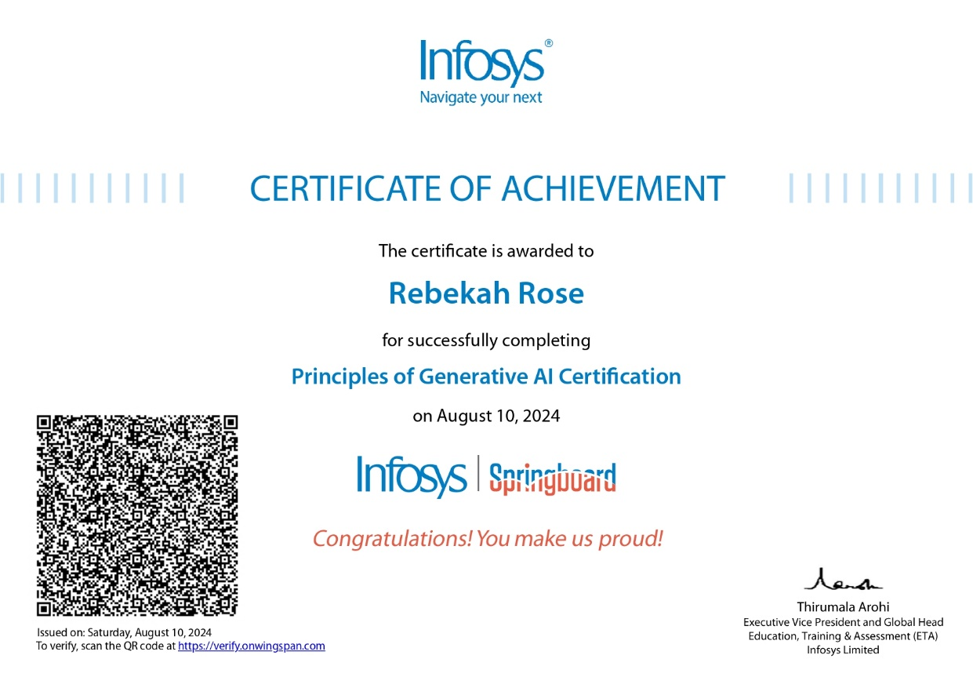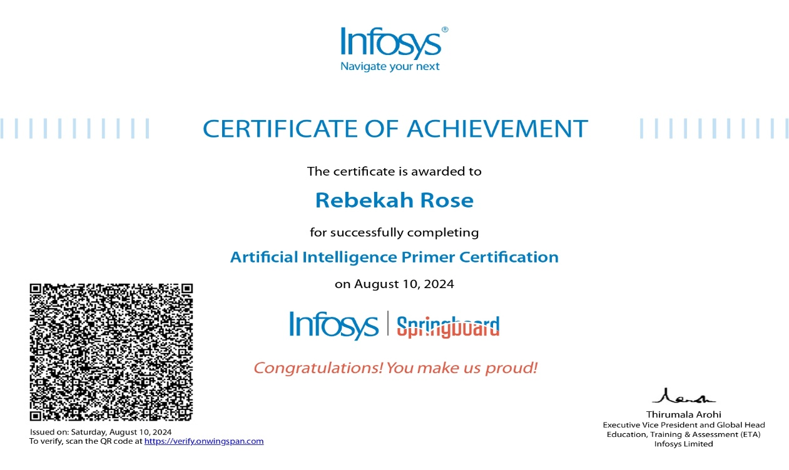

# AI/ML Internship Assignments and Tasks

**Day-1**8-10-2024

* Introduction to TumorTrace Project

Project TumorTrace focuses on using artificial intelligence (AI) to enhance breast cancer detection through MRI scans.

* Project dataset and basic concepts

Dataset used : <https://drive.google.com/file/d/1rKps09z1DEkfiICZlpIBOFek-LZ1vFAC/view>

The project aims to:

Improve Early Detection: Develop an AI model that analyzes MRI images to identify breast cancer at earlier stages than traditional methods.

Utilize Deep Learning: Implement deep learning algorithms, such as convolutional neural networks (CNNs), for accurate feature extraction and classification of tumors.

Validate Performance: Train and validate the model using a diverse dataset of MRI images, ensuring high accuracy and reliability.

Clinical Integration: Collaborate with healthcare professionals to create user-friendly tools for radiologists, facilitating seamless integration into clinical workflows.

Enhance Patient Outcomes: Ultimately, the project seeks to improve patient outcomes through earlier diagnosis and personalized treatment plans.

Dataset files:

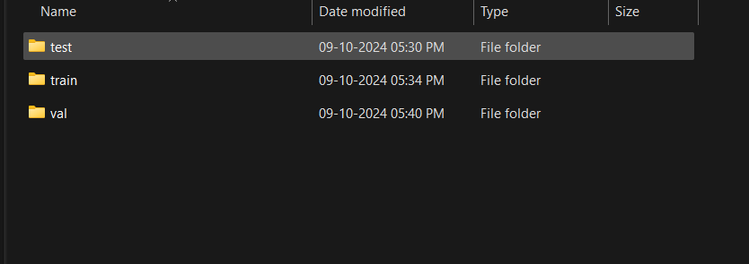

**Day-2**9-10-2024

### Setting up GitHub and Python Environments

Step 1: Install Prerequisites

1. Install Git from the official website.
2. Install Python from the official website, ensuring to add it to your system PATH. (installed version - Python 3.11.4)
3. Install Visual Studio Code from the official website.

Step 2: Set Up GitHub Repository

1. Create a new repository on GitHub, naming it (e.g., TumorTrace) and setting the desired visibility.

Step 3: Clone the Repository

1. Open the terminal in Visual Studio Code.
2. Clone your GitHub repository to your local machine.

Step 4: Set Up Python Environment

1. Navigate to your project directory in the terminal.
2. Create a virtual environment for your project.
3. Activate the virtual environment.
4. Install the required Python packages for your project.

Step 5: Open the Project in VS Code

1. Open your project folder in Visual Studio Code.
2. Select the Python interpreter associated with your virtual environment.

Step 6: Start Coding

1. Create new files for your project - Data.ipynb
2. Use Git to track changes and commit your work regularly.

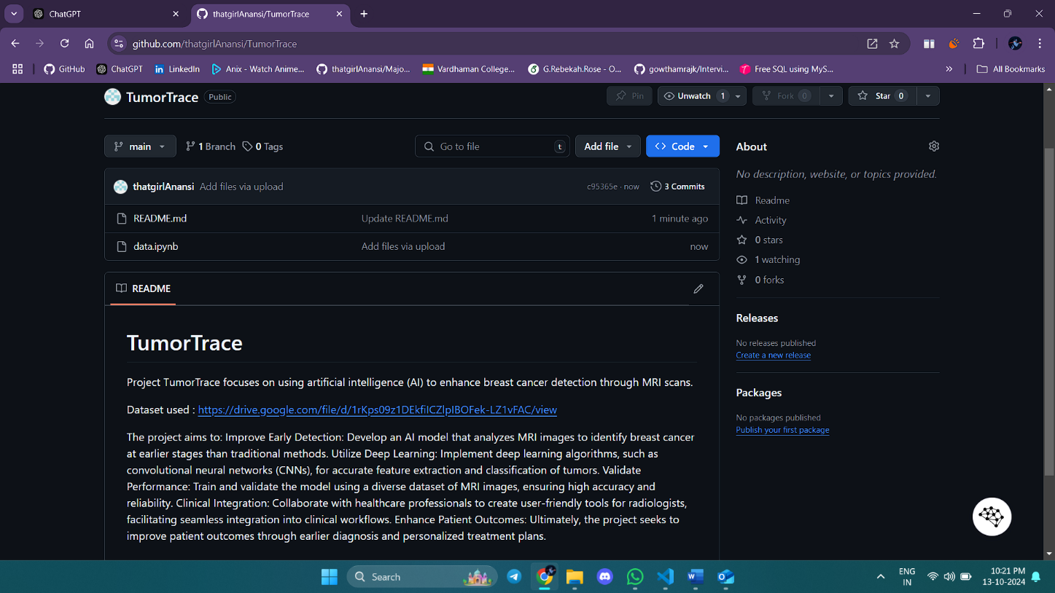

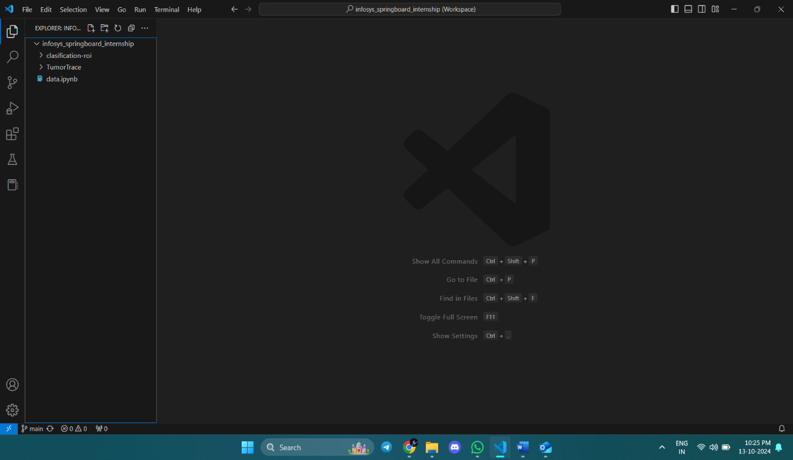

**Day-3**10-10-2024

* Understanding CNN architecture

Reference site - <https://poloclub.github.io/cnn-explainer/>

Brief Summary of the Content:  
The CNN Explainer is an interactive tool designed to help users understand the fundamental concepts behind Convolutional Neural Networks (CNNs), which are commonly used for image processing tasks in machine learning. Here’s a summary of its main features and content:

**Key Concepts**

1. **Convolutional Neural Networks (CNNs)**:
   * CNNs are a type of deep learning model that excels in processing and analyzing visual data, such as images. They are composed of several layers, each responsible for extracting different levels of features from the input image.
2. **Interactive Visualization**:
   * The tool provides a visual, hands-on way to learn about CNNs by showing how input images are processed step-by-step through different layers of a network. Users can interact with each component to see how the model extracts features, transforms data, and makes predictions.
3. **Layer Explanation**:
   * **Convolutional Layer**: Explains how the convolution operation extracts features from the image using filters. It shows how different filters can detect edges, textures, and patterns.
   * **Activation Layer**: Demonstrates the role of activation functions (like ReLU) in introducing non-linearity to the network, allowing it to learn complex patterns.
   * **Pooling Layer**: Describes how pooling (e.g., max-pooling) reduces the spatial dimensions of the feature maps, retaining important features while reducing computation.
   * **Fully Connected Layer**: Shows how the final layers take the extracted features and use them to classify images into different categories.
4. **Real-Time Examples**:
   * Users can upload their own images or use sample images provided to see how a CNN processes real-world inputs. This helps to understand how different layers contribute to the final output, which could be an object classification or identification.
5. **Educational Insights**:
   * The explainer offers educational tips, definitions, and simple explanations of complex concepts, making it easier for beginners to grasp how CNNs work. It covers terms like feature maps, kernels, and stride, and explains their significance in the network's functioning.

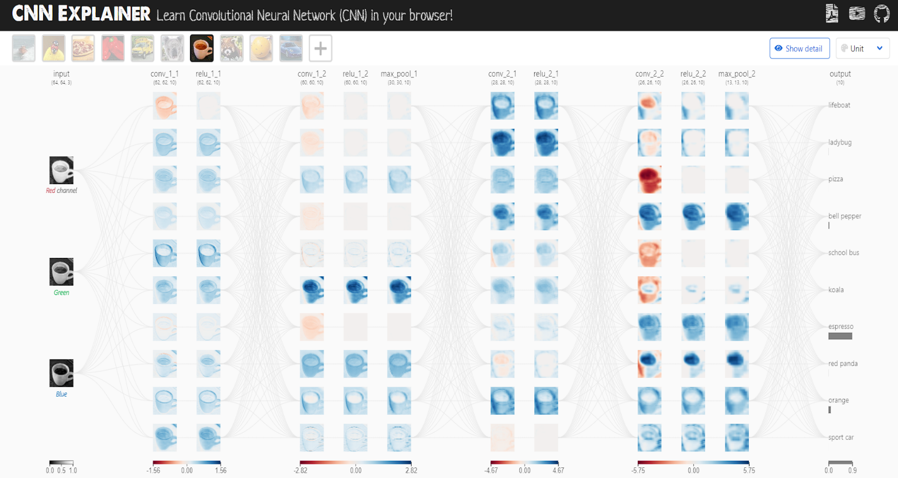

**Day-4**11-10-2024

### Performing Exploratory Data Analysis

**Transformation:** The transform in PyTorch is set to resize the images to (224, 224) and convert them to tensors.

**Dataset Loading:** Used datasets.ImageFolder to load images, which assumes a directory structure where each subdirectory is a class.

**DataLoader:** Creates batches and shuffles the dataset.

**Image Display:** Adjusted the method to filter and retrieve images of a specific class and converted tensors to NumPy arrays for displaying with matplotlib.

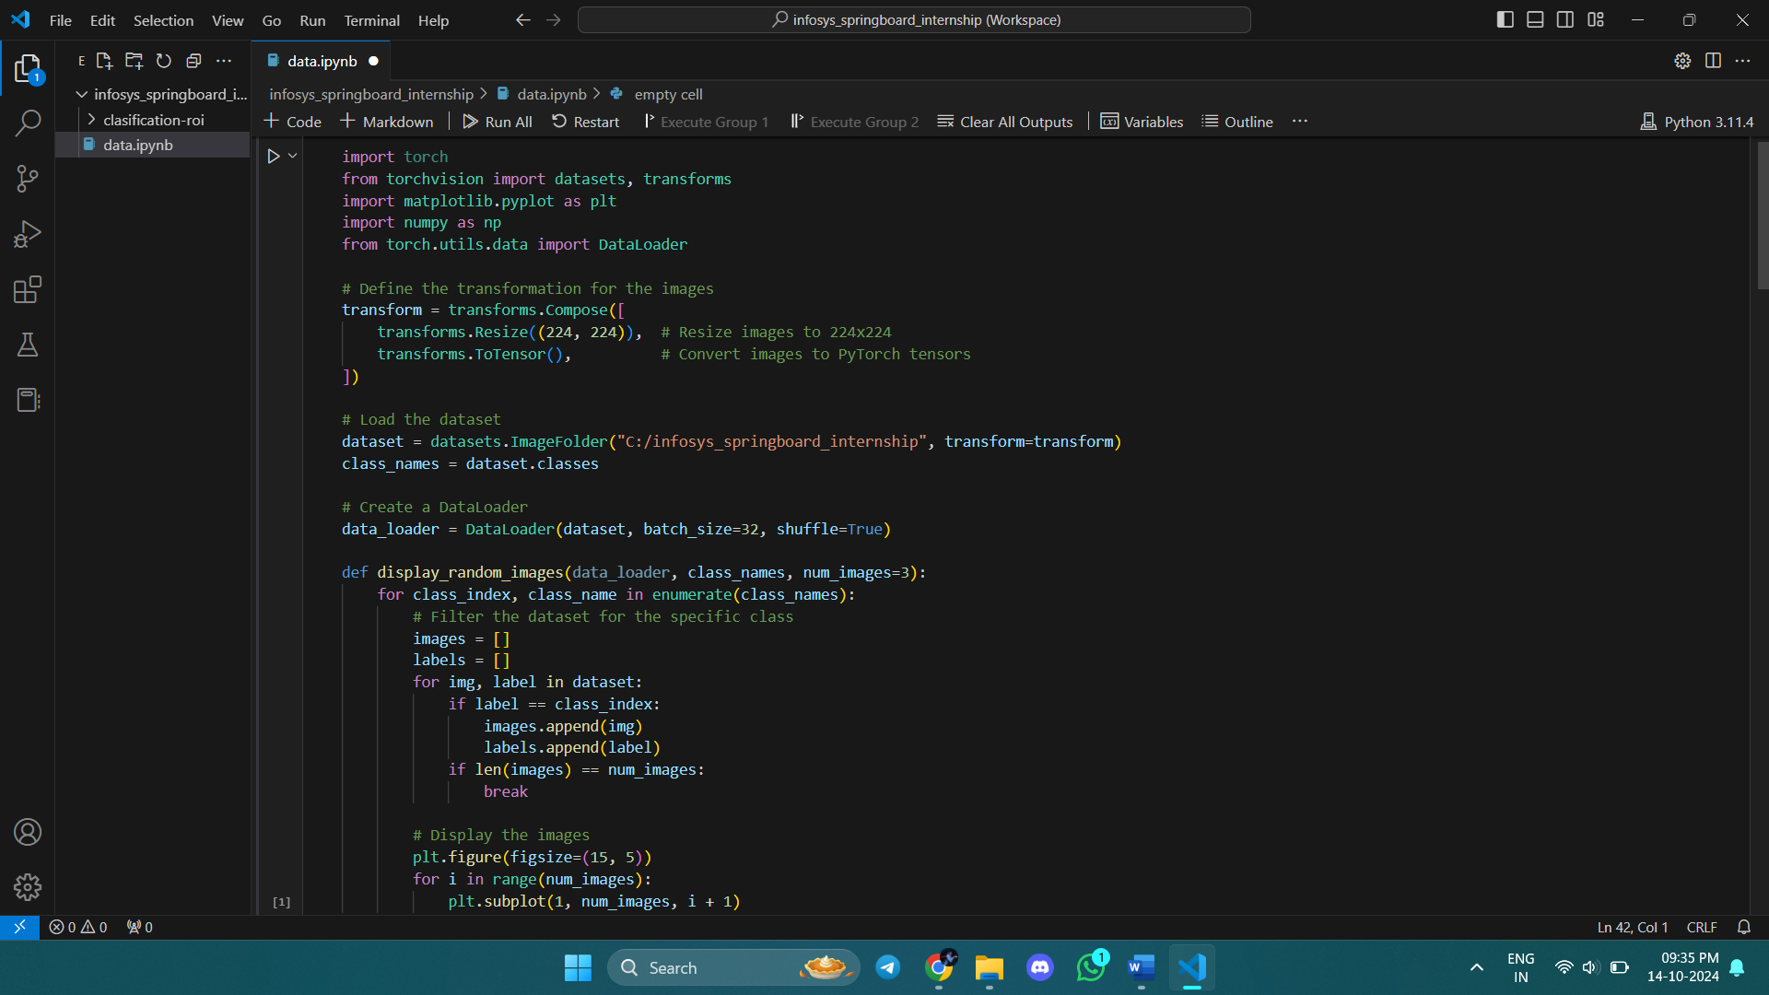

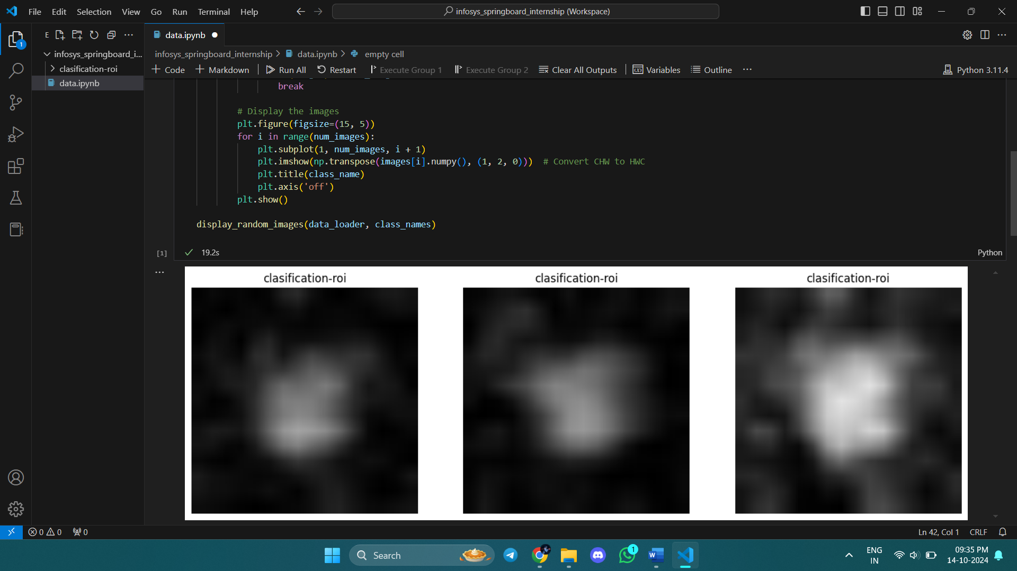

### Implementing data augmentation techniques

**Data Augmentation:** The code applies various transformations (resizing, flipping, rotation, zooming, and color adjustments) to augment the training images, enhancing dataset diversity for better model training.

**Dataset Handling:** It utilizes torchvision.datasets.ImageFolder to load images organized by class from a specified directory, along with a DataLoader for efficient batch processing and shuffling.

**Visualization**: A function is defined to display a specified number of augmented images, allowing for visual inspection of the transformations applied, which aids in understanding the data variations presented to the model.

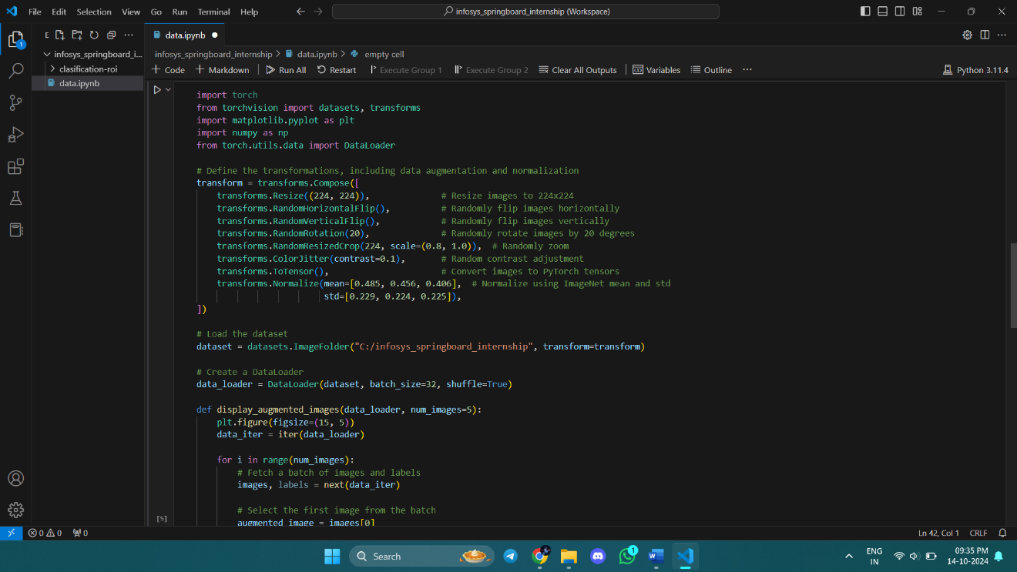

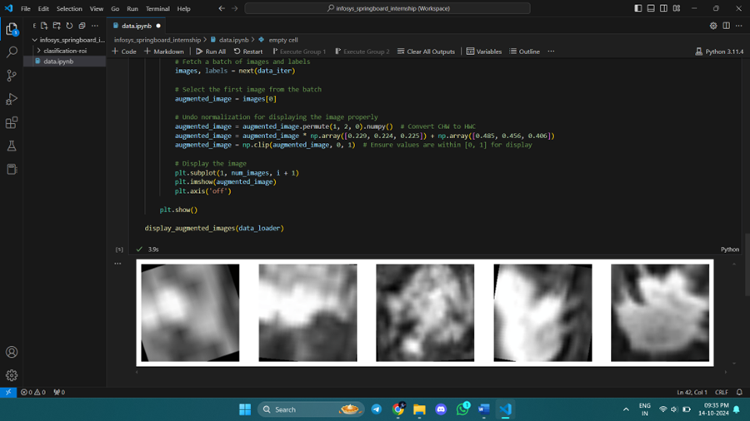

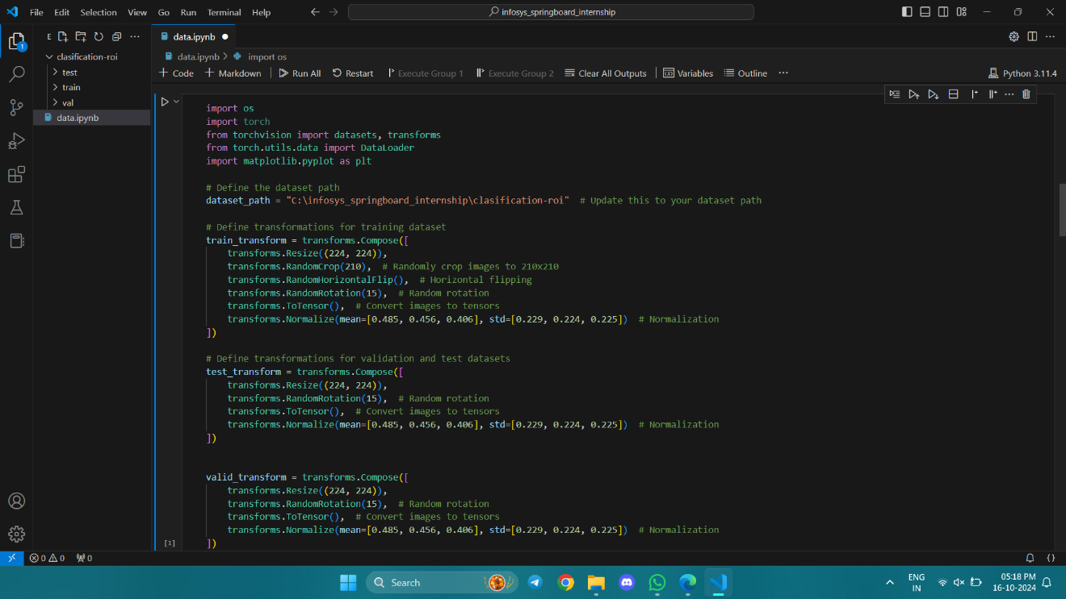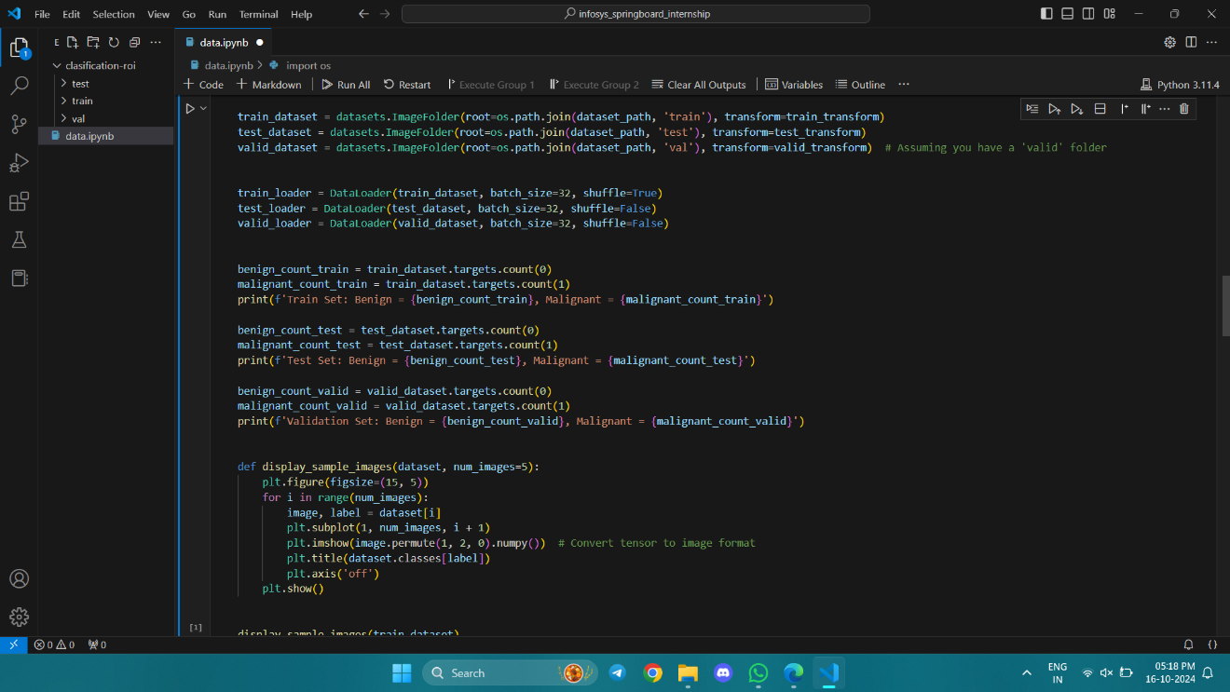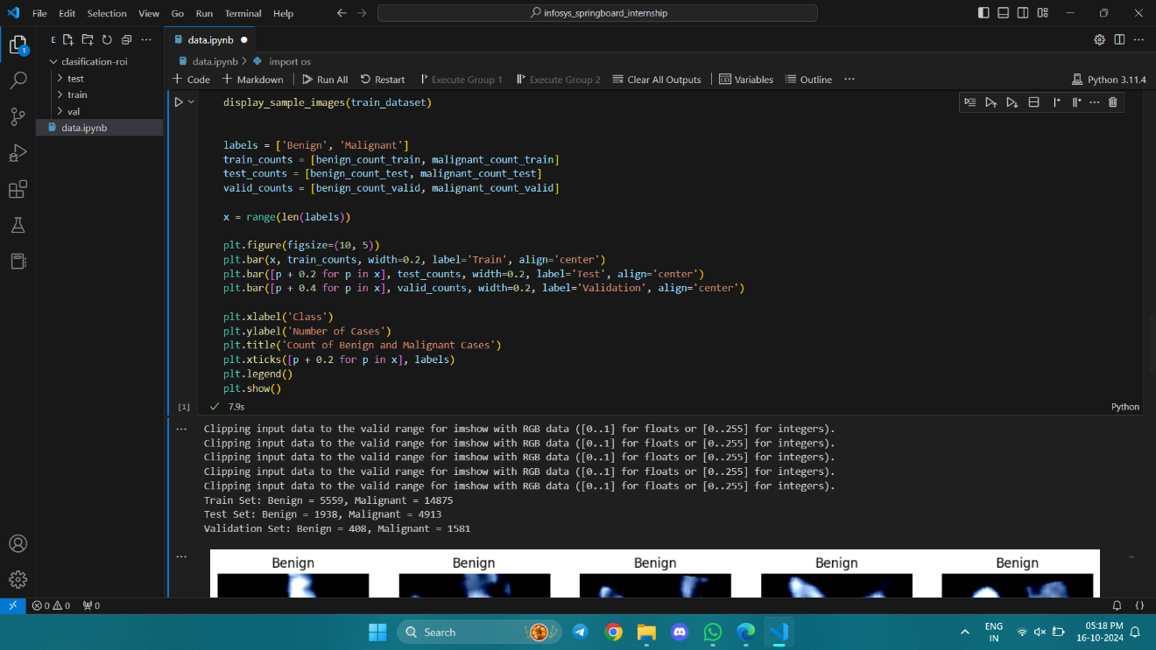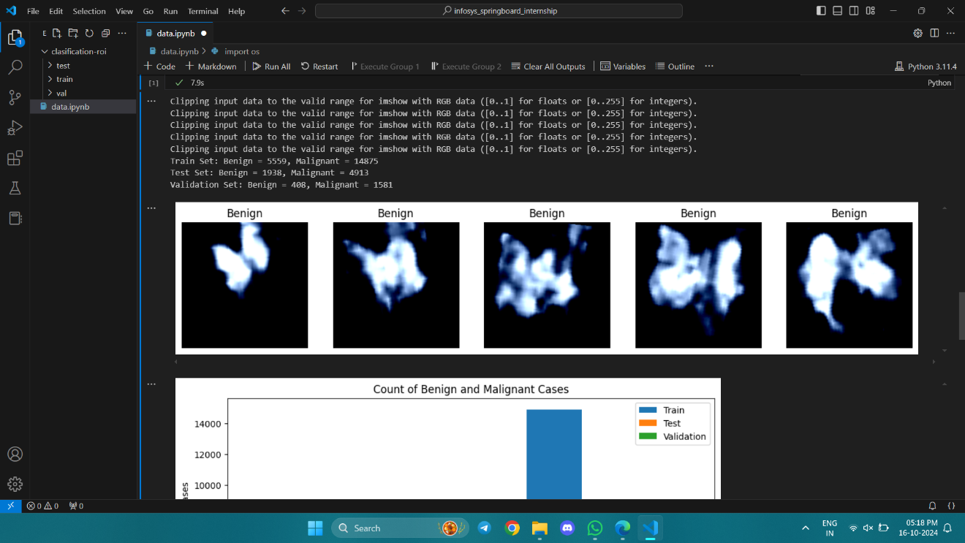

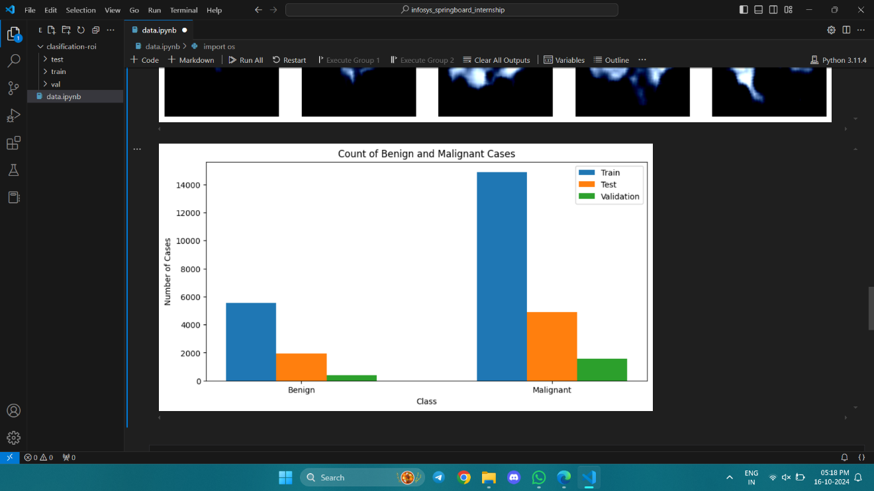

**Day-5**14-10-2024

Understanding ResNet and VGG16 architecture  
Reference: ChatGPT

**ResNet (Residual Networks)**

**Overview:** ResNet, or Residual Network, is a type of deep convolutional neural network (CNN) architecture designed to facilitate the training of very deep networks. Introduced by Kaiming He and his colleagues in their 2015 paper "Deep Residual Learning for Image Recognition," ResNet has become a foundational model in computer vision tasks.

**Key Features:**

**Residual Learning:**

ResNet introduces the concept of residual learning, where the network learns to predict the residual (the difference) between the input and the output of a series of layers. This is achieved through skip connections that allow the input to bypass one or more layers.

**Skip Connections:**

Skip connections (or identity mappings) help mitigate the vanishing gradient problem, which often occurs when training deep networks. By allowing gradients to flow directly through these connections, ResNet can train effectively even with hundreds or thousands of layers.

**Architecture:**

A typical ResNet architecture consists of multiple residual blocks, each containing two or three convolutional layers, followed by batch normalization and ReLU activation functions. The output of each block is added to the input (the shortcut connection), which enables the network to learn identity functions when needed.

**Depth:**

ResNet architectures can vary in depth, with common configurations including ResNet-18, ResNet-34, ResNet-50, ResNet-101, and ResNet-152, indicating the number of layers in the network. The deeper networks often achieve higher accuracy on complex tasks.

**Performance:**

ResNet has demonstrated remarkable performance in image classification tasks, notably winning the ImageNet Large Scale Visual Recognition Challenge (ILSVRC) in 2015. It has since been widely adopted in various applications, including object detection, segmentation, and more.

**Generalization:**

The architecture's ability to train deeper networks without overfitting makes it suitable for a wide range of applications, helping to improve generalization on unseen data.

**Impact and Applications**

**State-of-the-Art:** ResNet set new benchmarks in several computer vision challenges and has inspired a wide range of subsequent architectures, including DenseNet and EfficientNet.

**Transfer Learning:** Pre-trained ResNet models are commonly used in transfer learning scenarios, allowing practitioners to leverage the power of deep learning even with limited data for specific tasks.

**Broader Use:** Beyond image classification, ResNet has been adapted for tasks in natural language processing, audio recognition, and more, showcasing its versatility.

**Conclusion**

ResNet represents a significant advancement in the field of deep learning, particularly in training deep neural networks. Its innovative use of residual learning and skip connections has not only improved performance on various tasks but also laid the groundwork for future research and architectural innovations in the field.

VGG16 is a convolutional neural network architecture that was developed by the Visual Graphics Group (VGG) at the University of Oxford. It is widely used in the field of computer vision for image classification and feature extraction. Here are some key points about the VGG16 model:

**1. Architecture**

* **Depth**: VGG16 is a deep neural network with 16 layers that have learnable weights, hence the name VGG16. The architecture consists of:
  + 13 convolutional layers
  + 3 fully connected layers
  + 5 max-pooling layers
* **Convolutional Layers**: The convolutional layers use small 3x3 filters with a stride of 1. This small kernel size helps the network learn complex features while maintaining spatial resolution.
* **Pooling Layers**: Max-pooling layers with a 2x2 filter and a stride of 2 are used to down-sample feature maps, reducing the spatial dimensions while retaining important information.

**2. Input Size**

* VGG16 accepts input images of size 224x224 pixels. Images are typically preprocessed by subtracting the mean RGB value, calculated from the training set.

**3. Activation Function**

* The ReLU (Rectified Linear Unit) activation function is used after each convolutional layer to introduce non-linearity and help the model learn complex patterns.

**4. Fully Connected Layers**

* The fully connected layers at the end of the network consist of 4096, 4096, and 1000 units, respectively. The final layer uses the softmax activation function to output class probabilities for 1000 classes in the ImageNet dataset.

**5. Training**

* VGG16 was initially trained on the ImageNet dataset, which contains millions of images across thousands of classes. The model achieved significant performance, winning the ILSVRC (ImageNet Large Scale Visual Recognition Challenge) in 2014.

**6. Transfer Learning**

* VGG16 is often used for transfer learning due to its ability to extract features from images. Pre-trained VGG16 weights can be fine-tuned for specific tasks, allowing users to leverage the model's learned representations without requiring a large dataset.

**7. Applications**

* VGG16 is used in various computer vision tasks, including:
  + Image classification
  + Object detection
  + Image segmentation
  + Feature extraction for other models

**8. Limitations**

* While VGG16 is known for its simplicity and effectiveness, it has a large number of parameters (approximately 138 million), making it computationally intensive. This can lead to long training times and increased memory requirements.

**Conclusion**

VGG16 is a foundational model in deep learning and computer vision. Its architecture, characterized by small convolutional filters and deep layers, has influenced many subsequent models and remains a popular choice for image-related tasks, especially in the context of transfer learning.

**Day-6**15-10-2024  
  
Load a VGG16 Model  
  
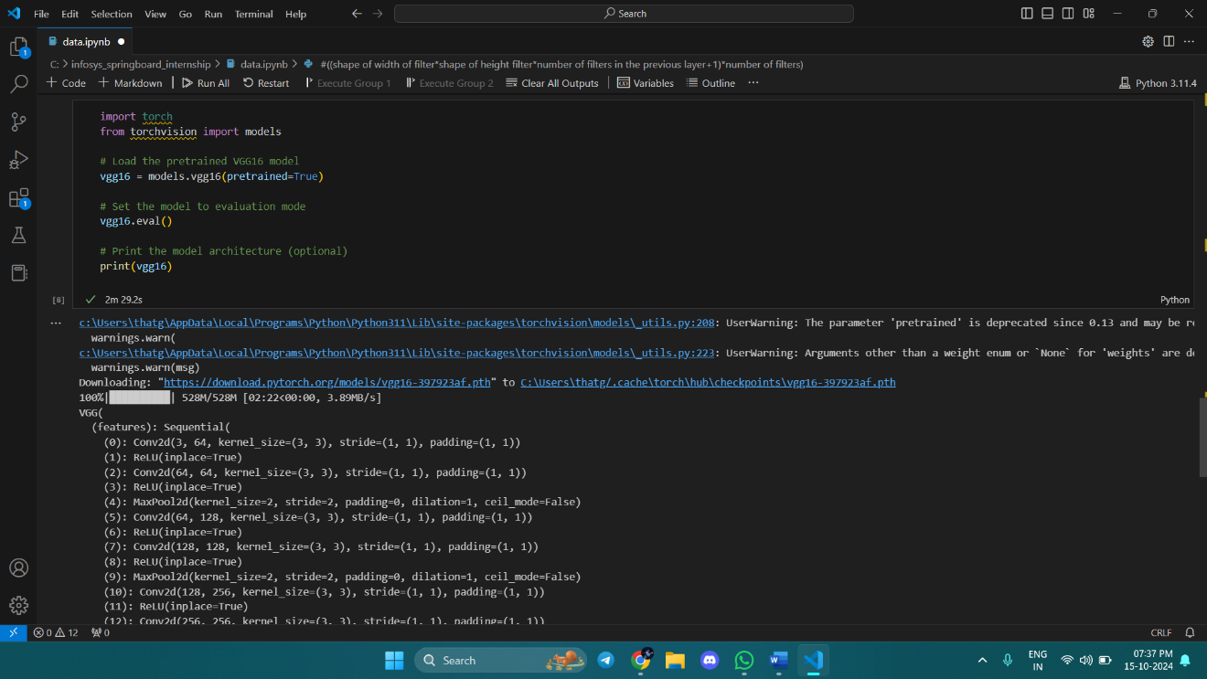

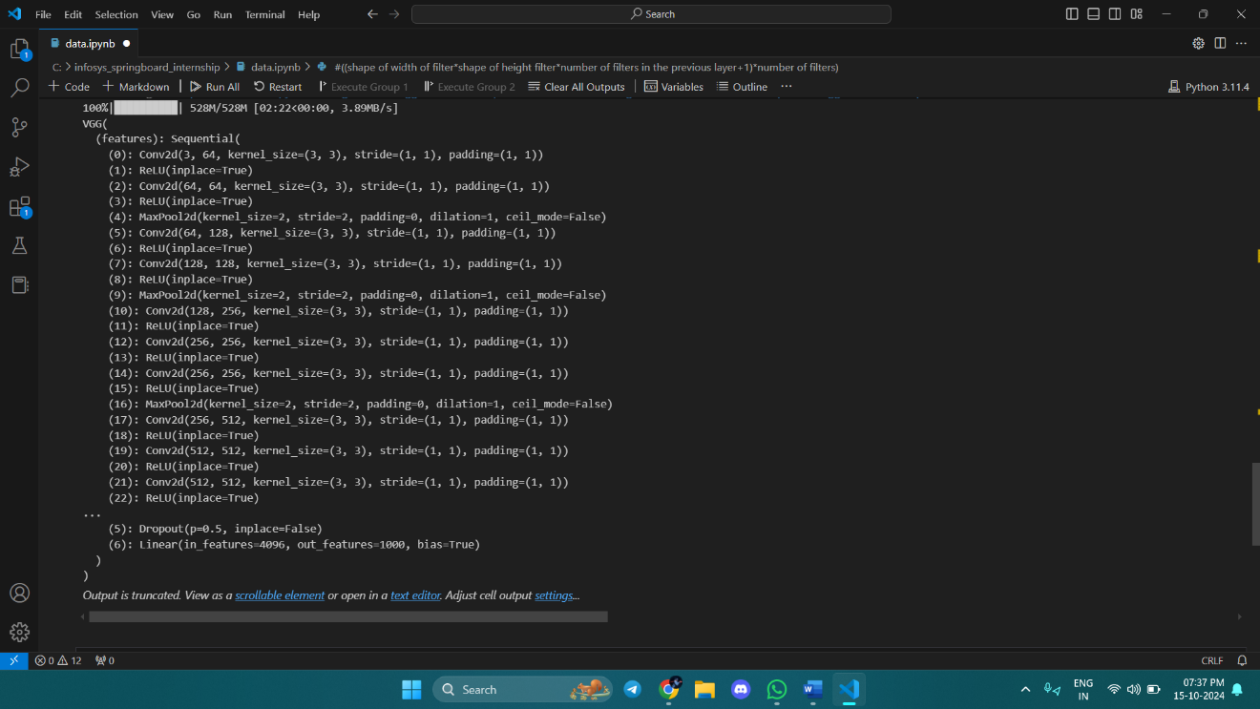

Why Convolutional Neural Networks (CNNs) are generally more efficient than fully connected networks for image classification ??

Reference: ChatGPT

1. Parameter Sharing

Weight Sharing: In CNNs, the same convolutional filter (kernel) is applied across the entire image. This means that the same set of weights is used to detect features at different spatial locations, significantly reducing the number of parameters compared to fully connected networks, where each input is connected to every neuron in the next layer.

2. Local Connectivity

Localized Feature Detection: CNNs utilize local receptive fields, meaning each neuron in a convolutional layer is connected only to a small region of the input image. This allows CNNs to learn spatial hierarchies of features, such as edges, textures, and shapes, which are crucial for image classification.

3. Spatial Hierarchy of Features

Layered Feature Learning: CNNs can learn features at multiple levels of abstraction. Early layers may learn simple features (like edges), while deeper layers can combine these features to recognize more complex patterns (like shapes and objects). This hierarchical representation is particularly effective for images.

4. Reduced Overfitting

Fewer Parameters: With fewer parameters due to weight sharing and local connectivity, CNNs are less prone to overfitting, especially when trained on smaller datasets. This allows them to generalize better to unseen data.

5. Translation Invariance

Feature Detection: CNNs exhibit some degree of translation invariance because the same filters are applied across the entire image. This means that objects in different positions can still be recognized effectively, unlike fully connected networks, which do not account for the spatial arrangement of features.

6. Pooling Layers

Dimensionality Reduction: CNNs typically incorporate pooling layers (like max pooling) to down-sample feature maps. This not only reduces the spatial dimensions of the data, making computations more efficient, but also helps in achieving invariance to small translations and distortions.

7. Computational Efficiency

Convolution Operations: The mathematical operations in CNNs, particularly convolution, can be computed efficiently using specialized hardware (like GPUs) and optimized algorithms. This allows CNNs to process large images quickly compared to fully connected networks, which involve more computationally intensive matrix multiplications.

8. Transfer Learning

Pre-trained Models: CNN architectures are often pre-trained on large datasets (like ImageNet), allowing them to leverage learned features for specific tasks. This makes them more efficient for image classification tasks, as they can achieve high performance even with limited training data.

Conclusion

Overall, CNNs are designed to exploit the spatial structure and patterns within images, making them more effective and efficient for image classification tasks compared to fully connected networks. Their architecture allows for better feature extraction, reduced computational requirements, and improved generalization, which are critical factors in achieving high accuracy in image-related tasks. Feature extraction is a crucial process in machine learning and computer vision that involves transforming raw data into a set of measurable characteristics (features) that can be used for analysis, classification, or prediction.   
  
  
  
About Feature extraction  
Reference: ChatGPT

1. Definition

Feature extraction refers to the process of identifying and isolating the relevant information or attributes from raw data. In the context of images, audio, or text, features are the characteristics that represent the essential content of the data.

2. Importance

Dimensionality Reduction: By focusing on key features, the complexity of the data is reduced, making models easier to train and less prone to overfitting.

Improved Performance: Well-chosen features can significantly enhance the performance of machine learning algorithms by providing them with relevant information.

Interpretability: Features can make it easier to understand the decision-making process of models, allowing for better insights into the underlying data.

3. Common Techniques

A. Image Feature Extraction

Edge Detection: Techniques like the Sobel operator, Canny edge detector, or Laplacian filter identify the edges in an image, which can be important features for object detection.

Texture Features: Methods like Local Binary Patterns (LBP) or Gabor filters analyze the texture of images, which can help in identifying patterns and objects.

Histogram of Oriented Gradients (HOG): This technique captures the distribution of directions of gradients, useful for detecting objects like pedestrians.

Convolutional Neural Networks (CNNs): CNNs automatically learn hierarchical features from raw pixel data. Different layers in CNNs extract features at varying levels of abstraction, from edges and textures to shapes and objects.

B. Text Feature Extraction

Bag of Words (BoW): This approach represents text data by counting the occurrence of each word in the document, disregarding grammar and order.

Term Frequency-Inverse Document Frequency (TF-IDF): This method weighs the importance of words in documents by considering their frequency in a specific document relative to their frequency in a corpus.

Word Embeddings: Techniques like Word2Vec or GloVe convert words into dense vectors that capture semantic meaning, allowing models to understand the relationships between words.

N-grams: This method involves creating sequences of n words (or characters) to capture context and local patterns in the text.

C. Audio Feature Extraction

Mel-Frequency Cepstral Coefficients (MFCCs): This technique is widely used in speech and audio processing to represent the power spectrum of sound.

Spectrograms: Visual representations of the spectrum of frequencies in sound, useful for analyzing audio signals and extracting features related to pitch and tone.

Zero-Crossing Rate: This measures the rate at which the audio signal changes from positive to negative or vice versa, providing information about the signal's noisiness.

4. Applications

Computer Vision: Object recognition, facial recognition, and image classification rely on effective feature extraction.

Natural Language Processing (NLP): Sentiment analysis, topic modeling, and machine translation depend on extracting meaningful features from text data.

Speech Recognition: Feature extraction techniques are essential for converting audio signals into text.

5. Challenges

Feature Selection: Identifying the most relevant features from a potentially vast set can be difficult. Irrelevant or redundant features can lead to poorer model performance.

Feature Engineering: The process of manually creating features can be time-consuming and requires domain expertise.

Overfitting: Including too many features can lead to models that perform well on training data but poorly on unseen data.

Conclusion

Feature extraction is a foundational step in data preprocessing that enhances the effectiveness of machine learning models. By transforming raw data into meaningful features, it enables algorithms to learn more efficiently and accurately, paving the way for advancements in various applications, from image recognition to natural language processing.  
  
Total number of parameters

The total number of parameters in the VGG16 model is **140,095,656**. This large number of parameters contributes to the model's ability to learn complex features but also makes it computationally intensive and prone to overfitting if not managed properly.

**Day-7**16-10-2024  
  
**Histogram of Oriented Gradients (HOG)** is a feature descriptor used in computer vision and image processing, primarily for object detection. It captures the structure or the shape of an object by analyzing the gradient directions (orientations) in localized parts of an image. Here's a breakdown of how HOG works:

**1. Key Concepts**

* **Gradient:** Measures the change in pixel intensity (brightness) in the image. It helps to detect edges and texture patterns.
* **Orientation:** The angle of the gradient. It shows the direction of the edges.
* **Histogram:** A representation of the distribution of gradients (how often each gradient direction appears).

**2. Steps to Compute HOG**

**Step 1: Preprocessing**

* The image can be resized to a standard size and, in some cases, converted to grayscale.
* Normalization can be applied to reduce the effects of lighting conditions.

**Step 2: Compute Gradients**

* The gradients of the image are computed using techniques like the Sobel operator.
* Gradients are calculated in both the horizontal (GxG_xGx​) and vertical (GyG_yGy​) directions

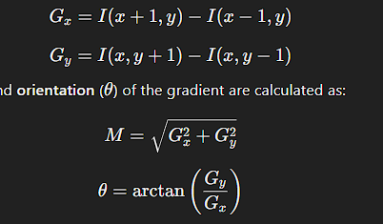

* **Magnitude** (MMM) and **orientation** (θ\thetaθ) of the gradient are calculated as:



**Step 3: Divide Image into Cells**

* The image is divided into small, square blocks (e.g., 8x8 or 16x16 pixels), called **cells**.
* Gradients are calculated for each pixel in the cell, and a histogram of gradient directions (orientations) is created.

**Step 4: Create Histograms**

* For each cell, a histogram of gradient directions is formed by quantizing the orientations into a fixed number of bins (e.g., 9 bins for 0° to 180°).
* Each pixel votes for a bin based on its gradient magnitude and orientation.

**Step 5: Block Normalization**

* To make the HOG descriptor invariant to lighting changes and shadows, several neighboring cells are grouped into a larger unit called a **block** (e.g., 2x2 cells).
* The histograms in the block are then normalized to ensure that the feature descriptor is not sensitive to variations in lighting.

**Step 6: Create the HOG Descriptor**

* The normalized histograms from all blocks are concatenated into a single feature vector, which serves as the final HOG descriptor for the image.
* This feature vector can then be used for machine learning tasks like classification or object detection.

**Advantages of HOG**

* **Robustness:** It is robust to variations in lighting and pose, making it useful for tasks like pedestrian detection.
* **Captures Local Features:** Effectively captures local edge structures, which are important for recognizing shapes.
* **Efficient Computation:** Computationally efficient and works well for real-time applications.

**Applications of HOG**

* **Object Detection:** Widely used for pedestrian detection in images and videos.
* **Face Recognition:** Can be used to extract features from faces, aiding in recognition systems.
* **Image Classification:** Serves as a preprocessing step for machine learning models, allowing them to learn meaningful patterns.

**Visualization**

To visualize HOG, it’s common to represent the feature descriptor by drawing lines that show the dominant gradient directions in each cell, providing insight into the edges and structures the descriptor has captured. This helps understand which features are contributing most to object detection.

plot the pixel value range from an image in a Histogram

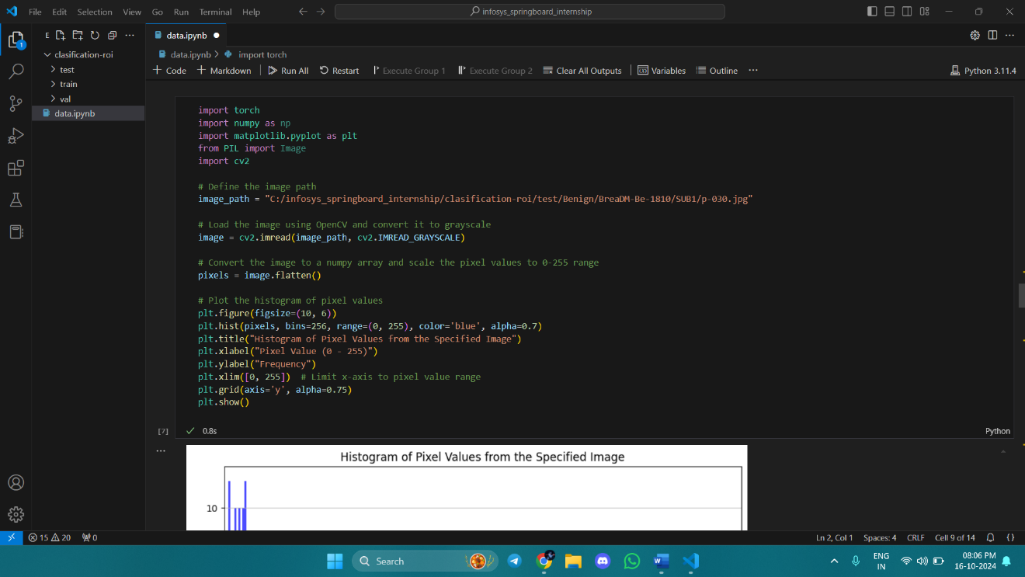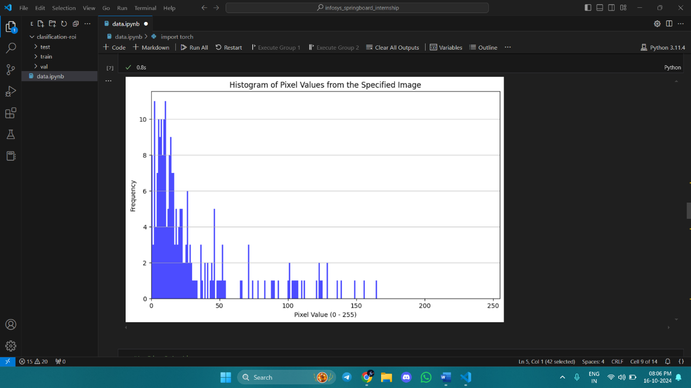

**Day-8**17-10-2024

implement Histogram of oriented gradients

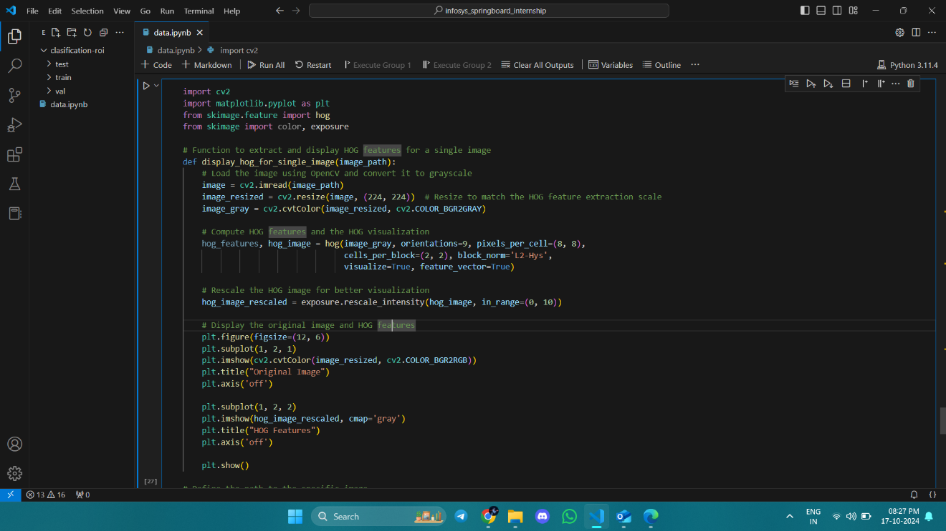

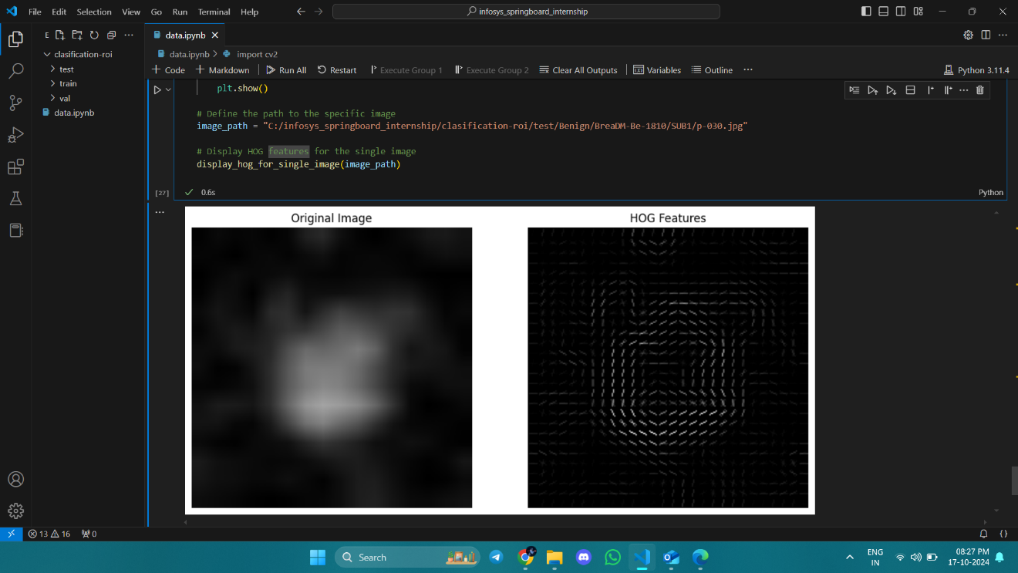

implement Corner and edge detection

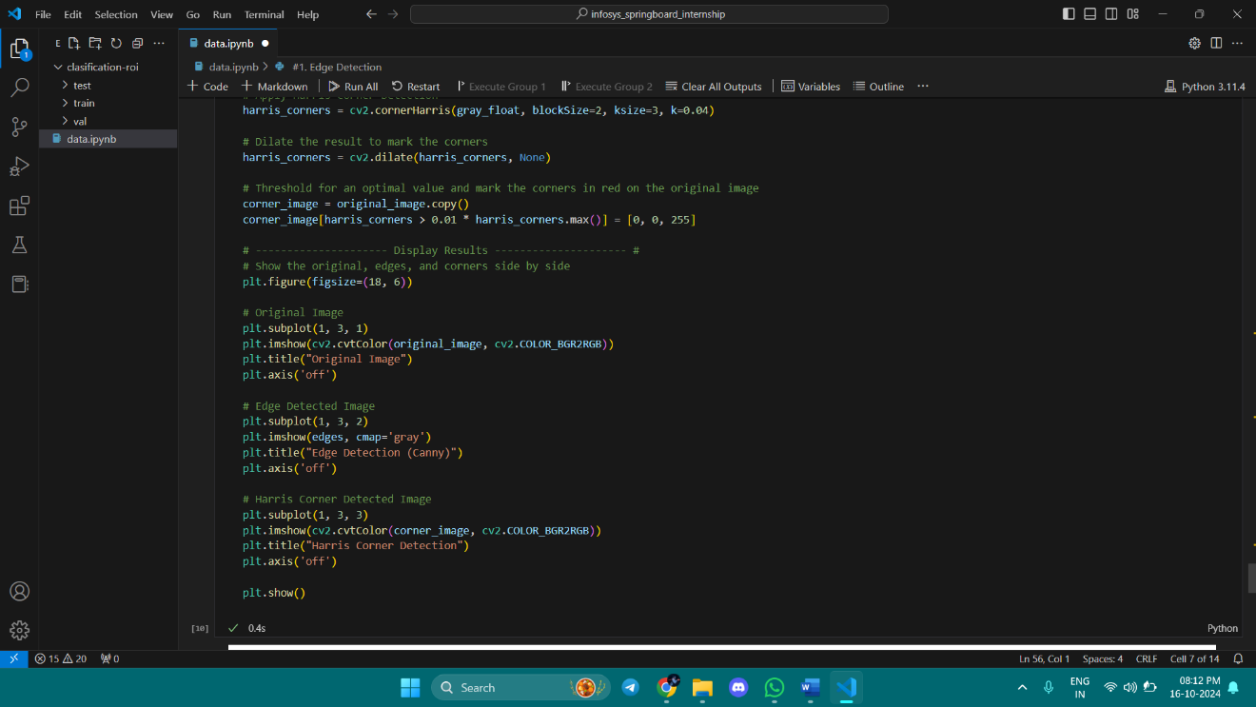

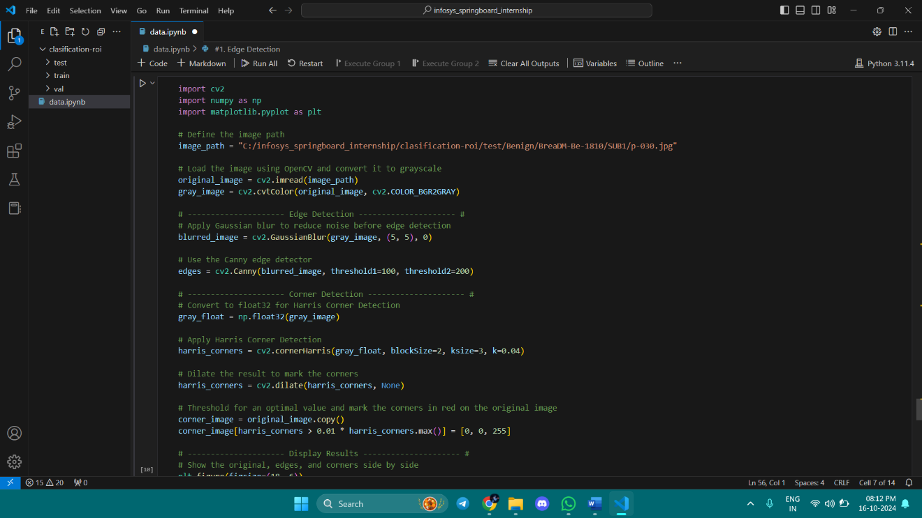

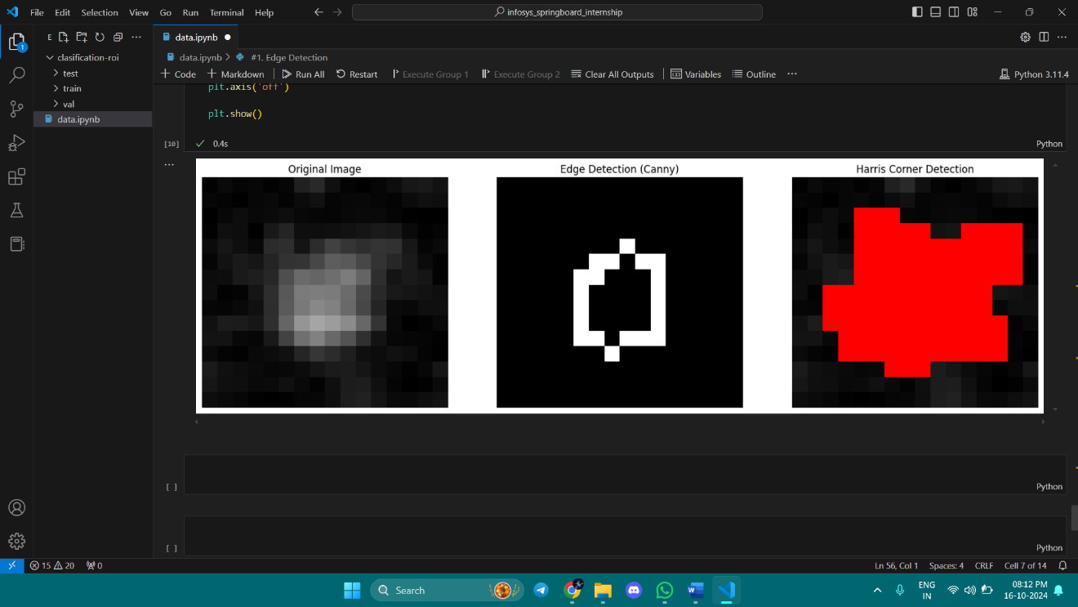

**Day-8**18-10-2024

**Day-9**21-10-2024

Implement Sobel Edge Detection

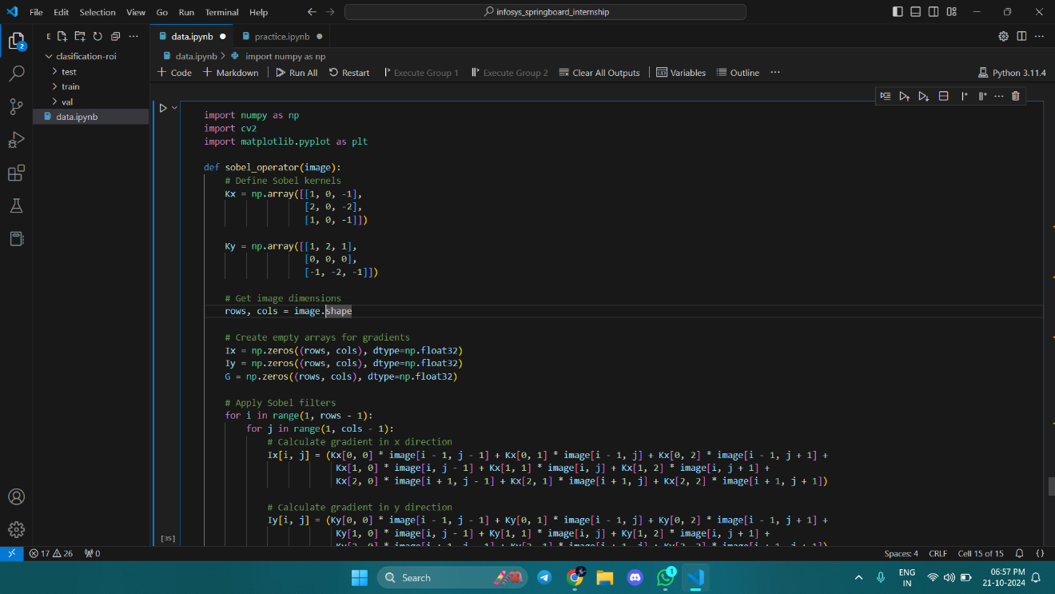

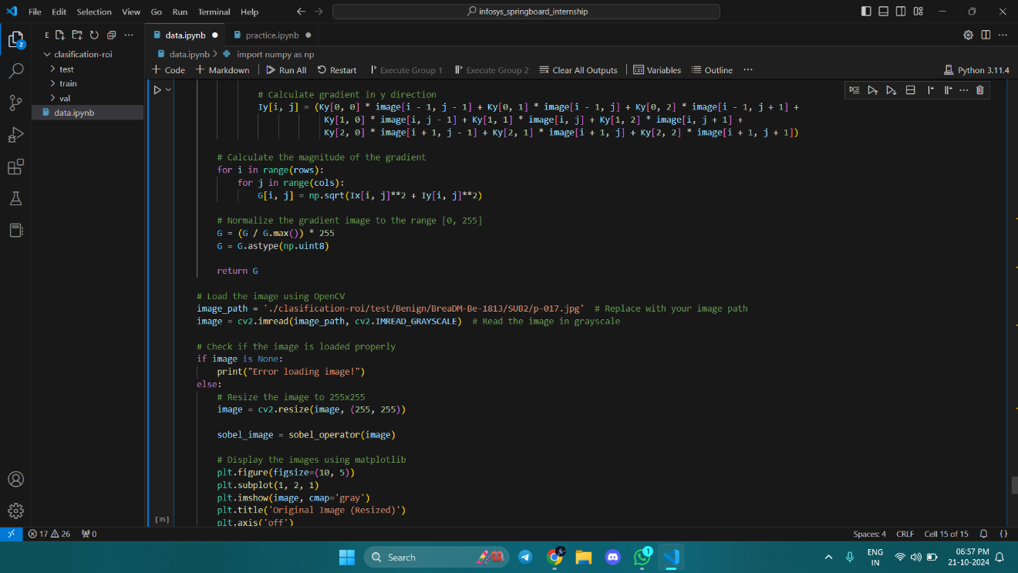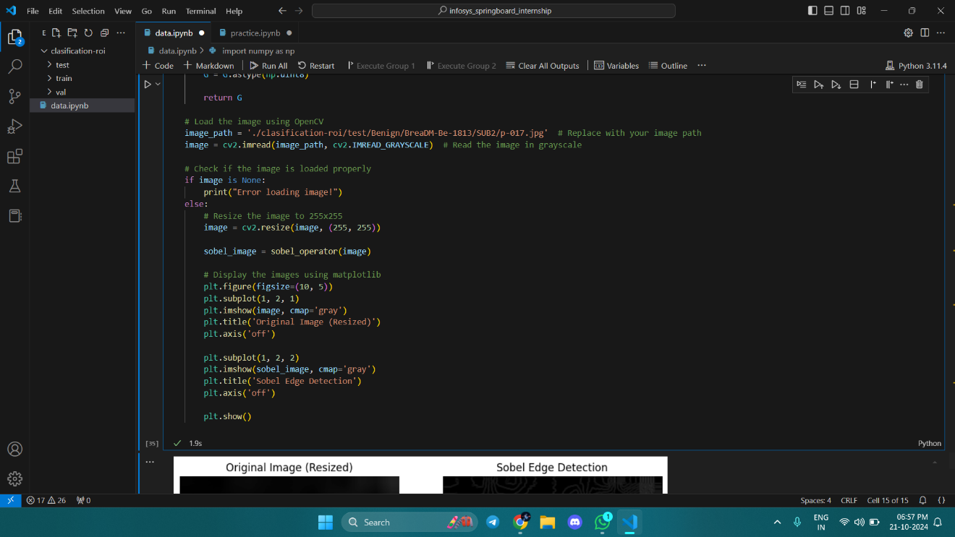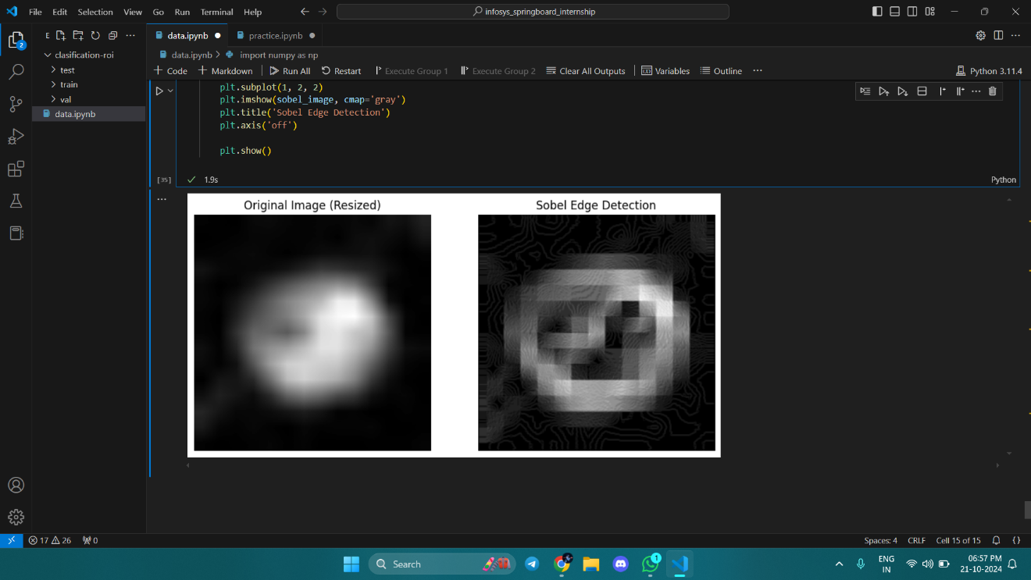

Here's a detailed explanation of the provided code, which implements the Sobel edge detection algorithm on an image using NumPy and OpenCV:

### Libraries Used

1. **NumPy**: A library for numerical computing in Python, providing support for arrays and mathematical functions.

2. **OpenCV**: A computer vision library that provides tools for image processing and computer vision tasks.

3. **Matplotlib**: A plotting library used for visualizing data, in this case, for displaying images.

### Code Breakdown

- **Import Libraries**: This imports the necessary libraries for the program.

### Sobel Operator Function

- **Function Definition**: Defines the `sobel_operator` function that takes a grayscale image as input and applies the Sobel operator to detect edges.

- **Sobel Kernels**: Defines the Sobel kernels `Kx` and `Ky` for detecting gradients in the x and y directions, respectively. These kernels are convolved with the image to compute the gradients.

- **Image Dimensions**: Extracts the number of rows and columns from the input image, which are used to create gradient arrays.

#### Create Empty Arrays for Gradients

- **Gradient Arrays**: Initializes three arrays:

- `Ix`: Stores the gradient in the x-direction.

- `Iy`: Stores the gradient in the y-direction.

- `G`: Stores the magnitude of the gradient.

#### Apply Sobel Filters

- **Loop Through Image**: Iterates through each pixel (excluding the borders) and applies the Sobel kernels to compute the gradients:

- **Gradient in X (`Ix`)**: Calculates the weighted sum of neighboring pixels using the `Kx` kernel.

- **Gradient in Y (`Iy`)**: Similarly, calculates using the `Ky` kernel.

#### Calculate Magnitude of the Gradient

- **Magnitude Calculation**: Computes the magnitude of the gradient at each pixel using the formula \( G(i, j) = \sqrt{Ix(i, j)^2 + Iy(i, j)^2} \).

#### Normalize the Gradient Image

- **Normalization**: Scales the gradient values to the range [0, 255] for visualization and converts the array to unsigned 8-bit integers (required for image representation).

### Main Execution Block

- **Image Loading**: Loads the image in grayscale from the specified path. If the image is not loaded properly, it prints an error message.

#### Resize the Image

- **Resizing**: Resizes the loaded image to 255x255 pixels using OpenCV's `cv2.resize()` function.

#### Apply Sobel Operator

- **Edge Detection**: Calls the `sobel_operator` function with the resized image to get the edge-detected output.

### Visualization with Matplotlib

- **Plotting**: Uses Matplotlib to create a side-by-side visualization of the original resized image and the Sobel edge-detected image.

- `plt.subplot(...)`: Sets up a grid for displaying multiple plots.

- `plt.imshow(...)`: Displays images with a grayscale colormap.

- `plt.axis('off')`: Hides the axis for a cleaner display.

- `plt.show()`: Renders the figure.

### Summary

- The code implements the Sobel edge detection algorithm from scratch, applies it to a grayscale image, resizes the image, and displays both the original and processed images side by side for visual comparison. The Sobel operator is a common technique in image processing for detecting edges based on the gradient magnitude.

**Day-10**22-10-2024

Implement local binary pattern

Reference link : <https://fairyonice.github.io/implement-lbp-from%20scratch.html>

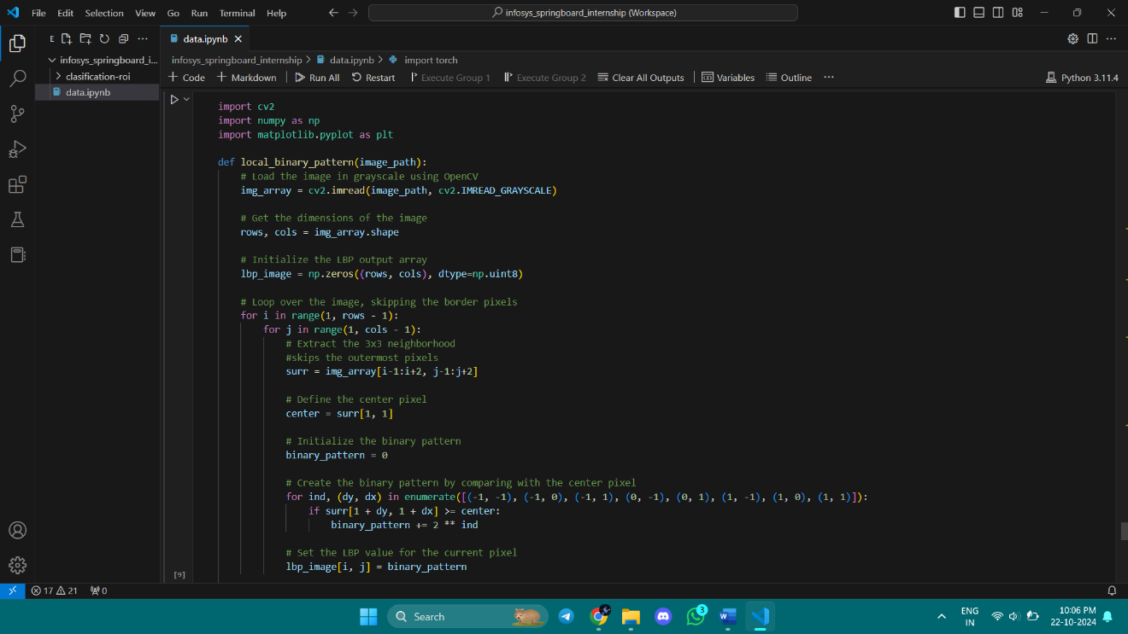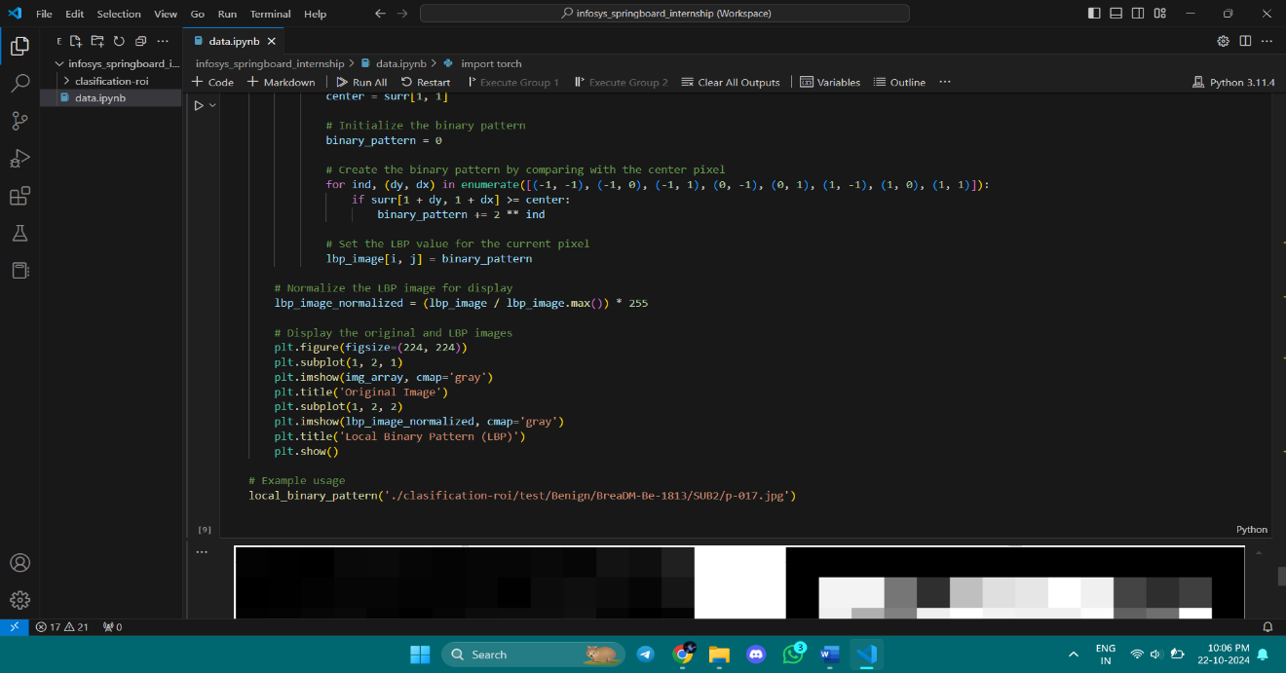

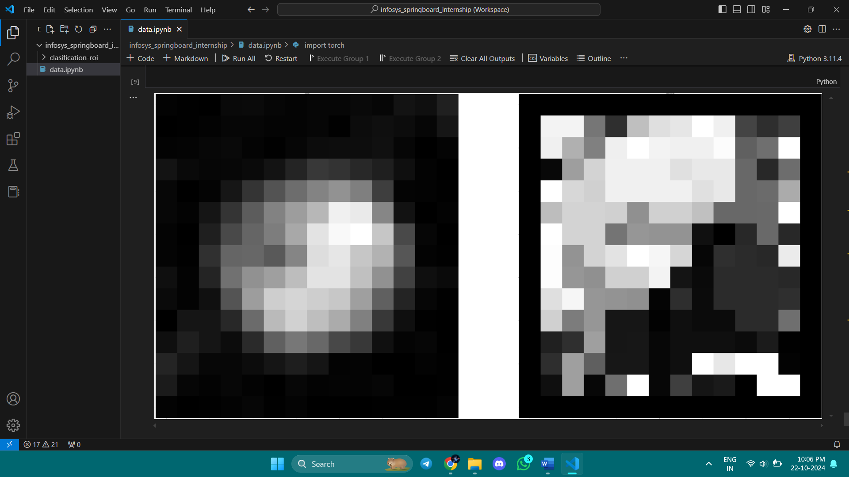

**Explanation:**

1. **Image Loading**:
   * **cv2.imread(image_path, cv2.IMREAD_GRAYSCALE)**: Reads the image from the specified path and converts it directly to grayscale. This is similar to the PIL method, but with OpenCV.
2. **Image Dimensions**:
   * Extracts the number of rows and columns (height and width) of the image.
3. **Initialize Output Array**:
   * Creates an empty array (lbp_image) with the same dimensions as the input image, initialized with zeros. It will store the LBP values.
4. **Iterate Through Each Pixel (Excluding Border)**:
   * Loops through the image, skipping the outermost pixels because the algorithm requires a 3x3 neighborhood.
   * **surr** stores the 3x3 neighborhood of each pixel, and **center** holds the middle pixel value.
5. **Compute Local Binary Pattern**:
   * Compares each of the 8 neighboring pixels with the center pixel.
   * **Binary Pattern**: If a neighboring pixel's intensity is greater than or equal to the center, set the corresponding bit to 1; otherwise, 0.
   * The resulting 8-bit binary value is converted to a decimal value.
6. **Store LBP Value**:
   * Assigns the calculated LBP value to the corresponding location in the lbp_image.
7. **Normalize for Display**:
   * Normalizes the LBP values to the range [0, 255] for consistent display.
8. **Visualize Original and LBP Image**:
   * Plots the original image and the LBP result side-by-side for visual comparison.

**Key Concepts:**

* **LBP (Local Binary Pattern)** is used for texture analysis and feature extraction by comparing each pixel's neighborhood.
* **Thresholding**: The comparison to the center pixel transforms local patterns into a binary code that represents textures.
* **Visualization**: Helps understand texture patterns across an image.

**Day-10**22-10-2024

Start the implementation of Mean binary points , Median Binary points and Variance Binary points

Reference Link: <https://assets-eu.researchsquare.com/files/rs-2022969/v1_covered.pdf?c=1662821973>  
  
Summary of the paper:  
**Key Concepts:**

* **Local Binary Pattern (LBP)**: A traditional technique used for texture classification and feature extraction in face recognition. It works by analyzing the pixel intensity variations in local regions of an image.
* **Mean−Variance−Median (MVM) based LBP**: The proposed method extends the classic LBP by incorporating three statistical measures—mean, variance, and median. This enhancement allows the method to capture more robust and discriminative features from the image, improving recognition accuracy.
* **Face Recognition**: Identifying or verifying a person's identity based on their facial features.
* **CBIR (Content-Based Image Retrieval)**: A system that retrieves images based on their visual content rather than text-based descriptions.
* **Feature Extraction**: The process of identifying and isolating significant patterns and characteristics from an image for further analysis.

**Methodology:**

The authors introduce the MVM-LBP, which combines mean, variance, and median calculations with the standard LBP to produce a feature vector that is more representative of the face's characteristics. This hybrid approach aims to make the system more robust against variations in lighting, expression, and other factors that could impact face recognition.

**Application:**

The method can be used for **face recognition systems** and has potential applications in security, access control, and surveillance systems. It can also be applied in **CBIR** systems to improve the retrieval of images based on facial features.

Implement mean binary points

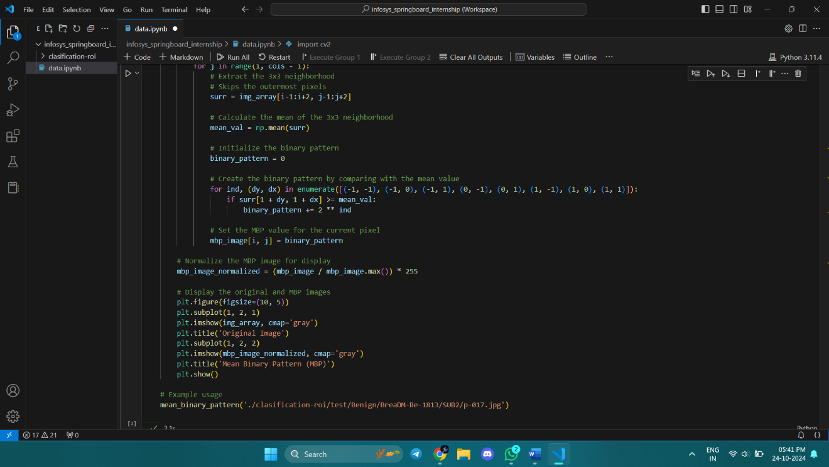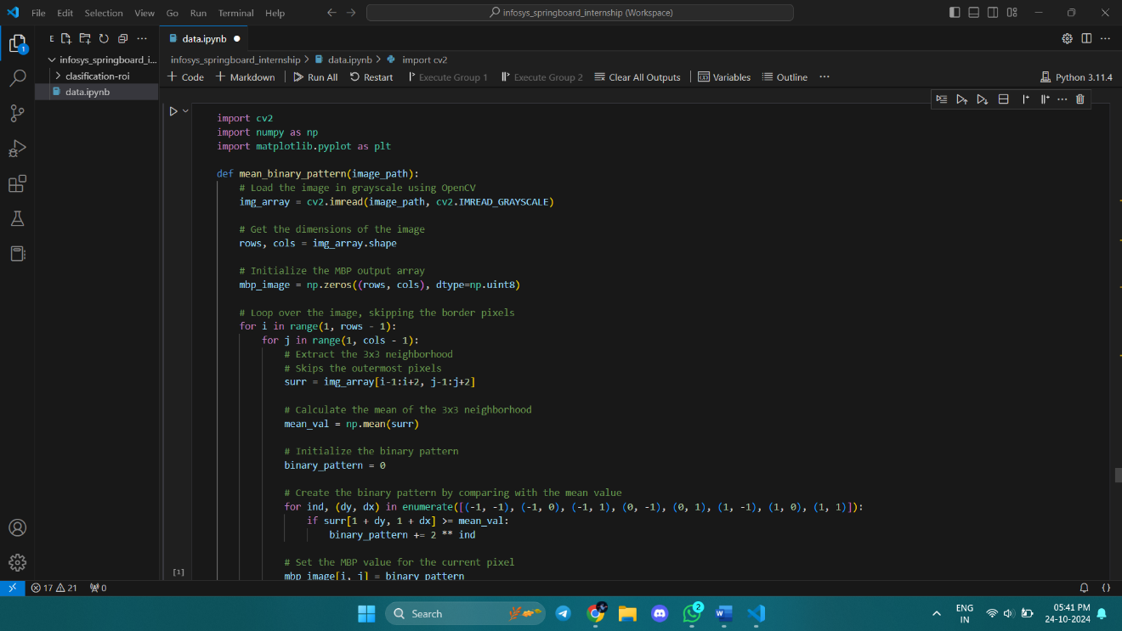

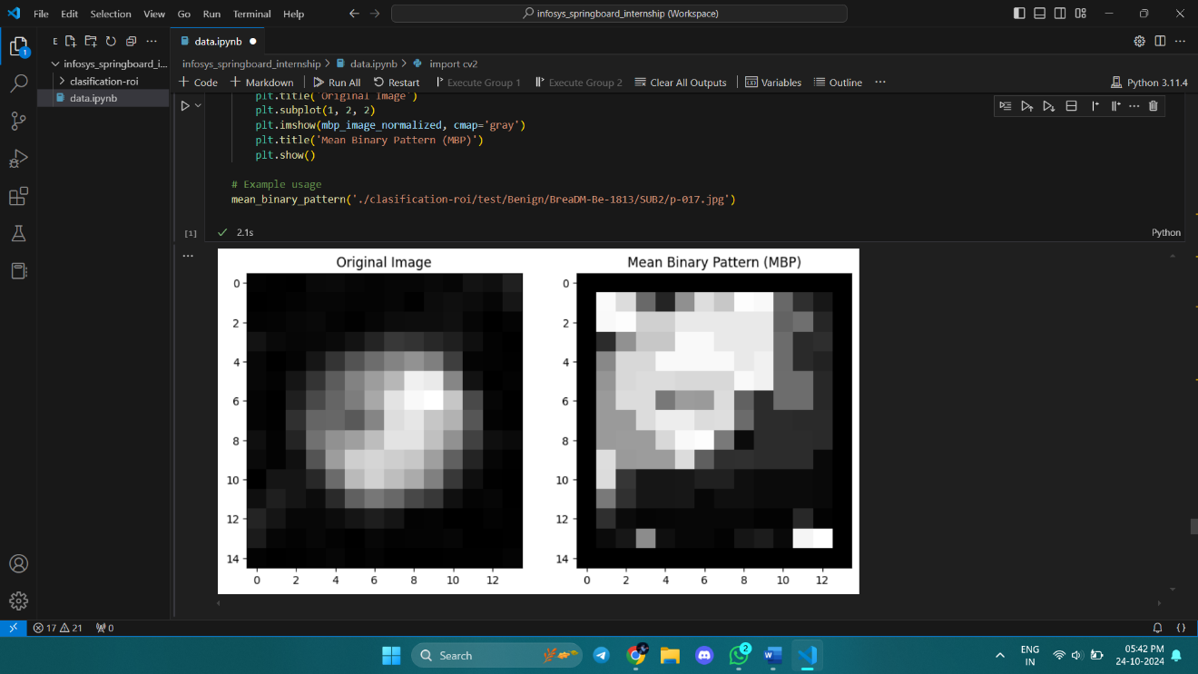

Implement median binary points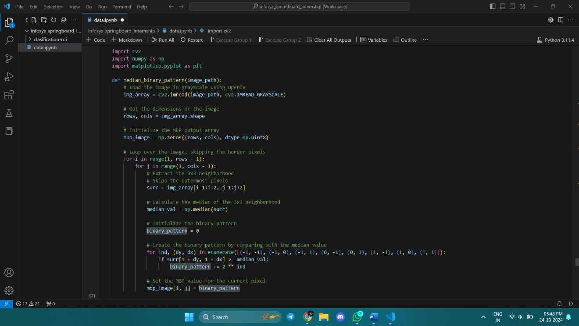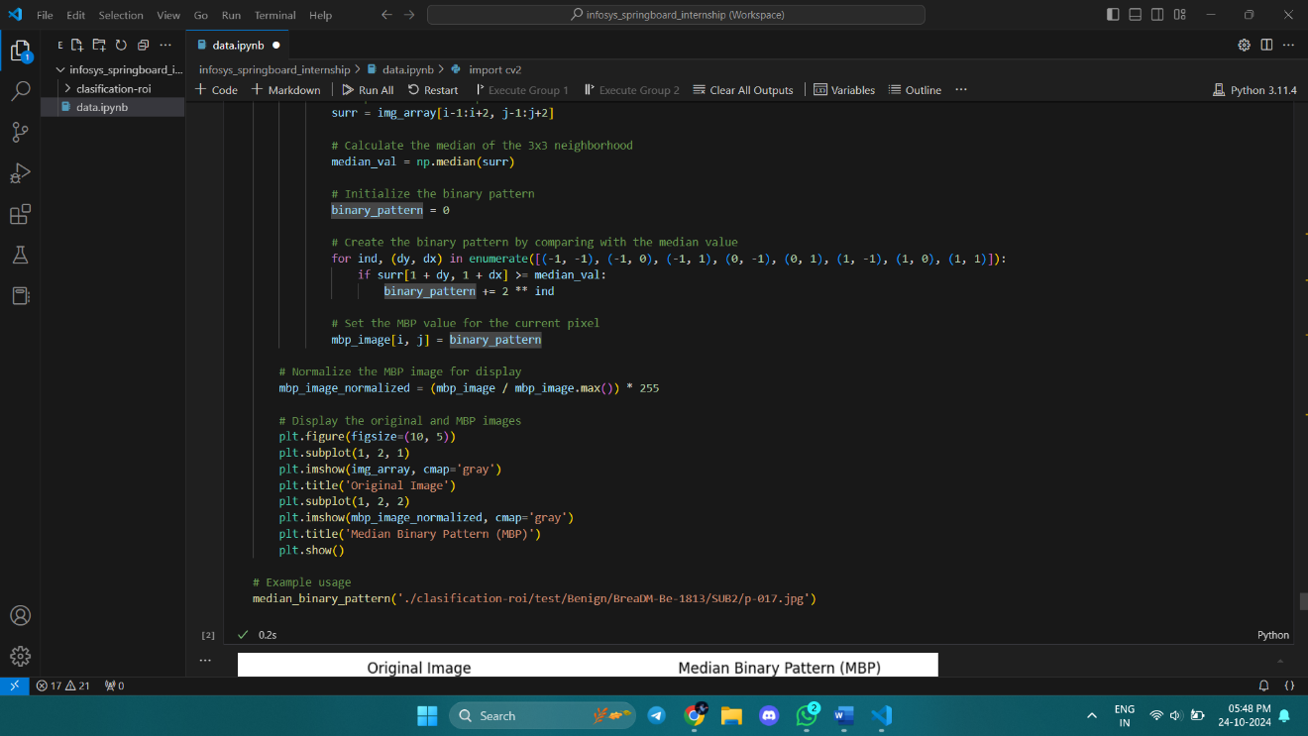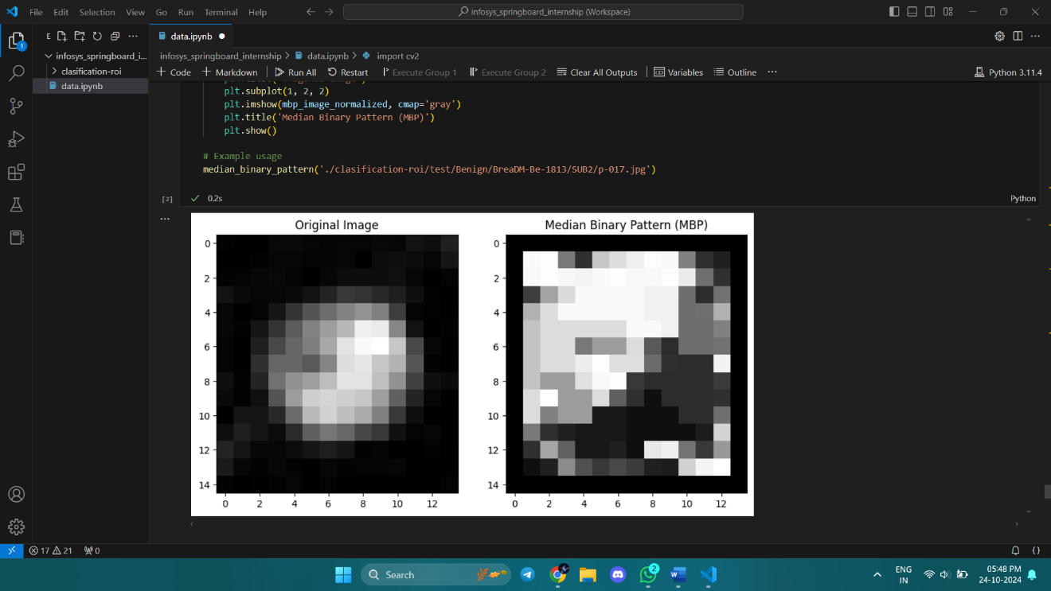

IMPLEMENT Variance binary points

